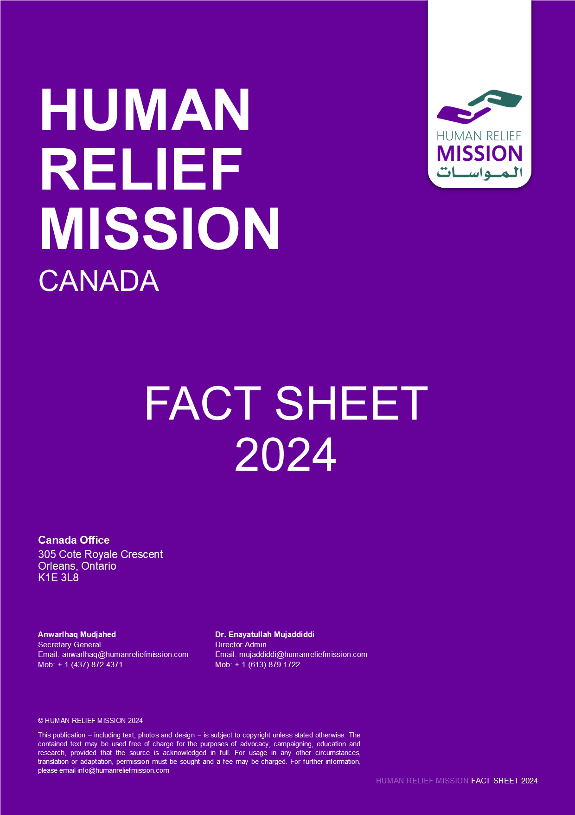

Nature of Organization
Human Relief Mission (HRM) is a non-governmental, non-political and not-for profit organization established and registered on April 08, 2024 in Ontario Canada to provide education, counseling, and other support services for refugees and other individuals in need, including language instruction, employment training, job-search activities, translation services, healthcare assistance, legal aid, and information programs on Canadian laws, culture and life.

Organization Mission:
HRM’s mission is purely for charitable purposes, particularly supporting education, health care, capacity building programs, and relief services

Organization Vision:
A Center of excellence and well known organization in providing humanitarian assistance in Canada and globally.

Organization Goal:
HRM’s overall goal is to provide humanitarian assistance and relief wherever there is a need.

Aims and Objectives of Organization:
- To provide education, counseling, and other support services for refugees and other individuals in need, including language instruction, employment training, job-search activities, translation services, healthcare assistance, legal aid, and information programs on Canadian laws, culture and life.
- To decrease poverty by providing basic necessities of life, including food, clean water, clothing, and/or shelter to individuals in need, with a focus on refugees in Canada.
- To advance education and relieve unemployment by providing employment-related training, leadership training programs, life skills workshops and mentorship to refugees and other individuals in need in Canada.
- To advance education by providing books, equipment, educational aids, tutoring services, and mentoring programs to youth in need, with a focus on those who are refugees in Canada.
- To advance education by collaborating with local schools and educational institutions to address any barriers to education facing youth, especially those who are refugees in Canada, to ensure their academic success.
- To provide culturally sensitive counseling services to address the trauma and mental health needs of refugees and underrepresented individuals and families.
- To organize community events, cultural celebrations, and recreational activities to promote social cohesion and integration for Canadians of foreign descent.
- To promote health by providing refugees and underrepresented individuals and families experiencing issues related to trauma and mental health challenges with access to culturally sensitive counseling, information, or group support programs.
- To promote health by facilitating networking opportunities and peer support groups in order to reduce isolation and build a sense of belonging among refugees and underrepresented individuals and families.
- To uphold human rights by advocating for the rights and needs of refugees and underrepresented individuals and families at all levels of government, and by engaging with policymakers, government agencies, and civil society organizations to address systemic barriers and promote inclusive policies.
- To regularly assess the effectiveness of the proposed activities and adjust them accordingly by utilizing feedback, surveys, and consultations with beneficiaries and stakeholders.
- To undertake activities ancillary and incidental to the attainment of the above purposes and such other complementary purposes not inconsistent with these objects.

HRM Legal Position:
HRM is a non-governmental, non for profit and non political Organization. HRM was established and registered by a group of members chaired by Anwarlhaq Mudjahed on April 8, 2024 in Ontario, Canada. HRM is registered with the government of Ontario with Registration number 1593159-2.

Due to the registration with all related authorities, HRM can work anywhere inside Canada without restrictions and has full authorization to seek financial resources and implementation possibilities for the planned projects. The organization is entitled to receive and accept gifts, grants, aids and donations from any donor agency.

HRM Policies:
HRM has the following policies:

- Vetting 3rd Parties Policy
- Social Media Policy
- Safety and Security Policy
- Risk Management Policy
- Procurement Policy
- Monitoring and Evaluation Policy
- Preventing Bribery and Corruption Policy
- HR Policy
- Global Sanctions Policy
- Fundraising Policy
- Data Protection Policy
- Financial Policy and Procedure
- Child Protection Policy
- Anti Money Laundering Policy
- Anti Fraud and Anti Corruption Policy

Administrative System of HRM :
As mentioned HRM has policies, manuals and guidelines for all programs and projects’ administration and management.

The organization conducts different surveys across the country, collects information and prepares proposals on the needs of the poor and vulnerable people, pointing out the difficulties and problems of the people to the donor agencies.

Beside the permanent staff, consultants and volunteers the organization hires project based staff for the approved and contracted projects accordingly.

As mentioned Human Relief Mission has a global presence notably in Ottawa/Ontario Canada as well as Afghanistan, Norway and its head office in the United Kingdom with all Offices registered with its respective country's relevant authorities abiding by local charity law. The head office in the UK sets the vision and mission of the organization and in terms of project planning, implementation, supervision and M&E is overseen by the head office.

All HRM offices have established a chain of commands with the Country Director reporting to Human Relief Mission UK and to ensure correct and efficient reporting program manager, program officers, regional coordinators and relevant support staff exist. Administrative staff respective of their office are responsible for reporting, volunteer engagement & management, reconciliation of walk-in donations.

Financial System of HRM:
As mentioned HRM is an organization working in several countries. The organization conducts needs assessments for strengthening, rehabilitation and humanitarian relief for those in need and submits them in the form of project proposals to donor agencies.

The organization has qualified staff in accounting and while preparing proposals, the organization's team of accountants prepare financial proposals for the planned project activities, where all the budget is planned and budgeted with Budget breakdown for the budget follow-up, reconciliation and reporting.

The Financial officers, Assistants and cashiers then follow the budget utilization, regularly prepare the reconciliations on a monthly basis and prepare financial reports to be submitted to donors, relevant governmental departments and HRM main office. All the supporting documents in terms of requests, purchase order, quotations, invoices, bills, GIN, GRN and other required supporting documents are maintained with the financial reports according to the HRM Financial Manual.

HRM Finance Department prepares financial reports on the quarter base to the donors and governmental relevant ministries in Quick Book, Cash Book, Journals and other donors and governmental required systems.

Staffing and organization:
Human Relief Mission has currently appointed 4 qualified staff on the following positions for the Canada Office and they are as following:

- HRM Secretary General
- HRM President
- HRM Treasurer
- HRM Director Admin

The remaining staff will be assigned, recruited and deployed based on project needs and as deemed necessary by the senior leadership team for HRM Canada Office.

Monitoring and evaluation:
HRM M&E Officer as well as the senior Program and Project staff regularly monitors and evaluates the project activities according to the M&E policy and guideline..

M&E officers regularly prepare its report after every mission and submit it to the General Director and Program Manager.

The Director and PM then evaluate the report and instruct the Project Managers, Officers and relevant staff for the action plan and post follow ups.

Canada:

Bank: TD
AC Name: Human Relief Mission
AC No: 5248904
Institution No: 004
Transit No: 33156
SWIFT: TDOMCATTTOR

HRM Background in Terms of Completed and Implemented Projects:
Human Relief Mission has over 10 years on the ground experience assisting those in need around the world and acting as a beacon of hope for those that have lost their livelihoods and have been succumbed to disadvantages their whole life.

We have a proven track record of delivering aid in the following sectors:

- Emergency Relief in the aftermath of natural disasters and war
- Provision of Food Aid i.e. food packs and hot meals
- Income generating programs to provide sustainable income for underprivileged households
- Education Sponsorship Programs
- Women empowerment programs
- Reforestation Programs
- Refugee Support Activities
- Cultural Awareness programs for refugees settling in the UK and Norway

Detailed program outlines can be found on HRM’s website and social media platforms.

The Canada office is currently conducting needs assessments and searching for sources and resources to help implement programs in Ontario, Canada as well as build and establish relationships with
Currently HRM Canada office is survey, assessing and searching the needs, sources and resources as well as the opportunities, partnerships and funding sourcing for the HRM Programs, Projects and Activities in Ontario Canada.

Besides looking for the regular opportunities, the leading group of HRM is supporting newcomers with job placements, guidance and helping them with their refugee applications and other required documents. HRM also provides community integration awareness sessions to individuals in need.

HRM’s Completed Projects in Canada:

      - New Horizon for Senior Program:
Project Name: Empowering Afghan Seniors for Active Citizenship
Funded By: Ministry of Employment and Social Development of Canada (ESDC).
Date: March 2025- March 2026
Over the project period, a total of 30 Afghan seniors (20 men and 10 women) were identified, registered, and actively engaged through structured outreach and community collaboration. The project delivered 10 culturally sensitive awareness sessions, covering key topics such as Canadian laws and seniors’ rights, access to healthcare services, financial literacy, social services, volunteerism, healthy aging, housing and care options, civic engagement, intergenerational relationships, and elder abuse prevention. These sessions were supported by guest speakers and tailored to address language barriers and cultural considerations, ensuring accessibility and relevance. The sessions were conducted in Pashto, Dari and English languages for better understanding of the participants.

      - New Horizon for Senior Program:
Project Name: Empowering Afghan Seniors through technology and Community
Funded By: Ministry of Employment and Social Development of Canada (ESDC)
Date: March 2026- March 2027 (On going)

Over the project period, a total of 30 Afghan seniors with more focus on Female Afghan seniors were identified, registered, and actively engaged through structured outreach and community collaboration. The project delivered 12 culturally sensitive awareness sessions, covering key topics of Digital Literacy such as; Introducing to digital devices, Using the internet safety, Setting Up and Using Email, Video Calling and Messaging Apps, Using Smartphones and Mobile Apps, Online Safety and Privacy, Accessing Government and Community Services Online, Online Banking and Financial Literacy, Using Google Services, Social Media Basics, Digital Health Tools, Digital Etiquette and Communication
These sessions were supported by guest speakers and tailored to address language barriers and cultural considerations, ensuring accessibility and relevance. The sessions were conducted in Pashto, Dari and English languages for better understanding of the participants.

      - Partnership with ICNA Relief Canada: Facilitating and Supporting partnership with ICNA Relief Canada in the Emergency Responses of Earthquake Relief, Ramadan Relief, EID-Adha Support Programs.

      - Social Support Club/Help Clinic/Family Clinic:

HRM through its social support programs provides support to newly arrived families and individuals with their Immigration and citizenship applications, filling in documents and forms, getting appointments, applying to employments, navigating and exploring existing services, etc.

HRM Way forward in Ontario Canada:
- Mobilizing resources for establishing a Community Center.
- Community Services Center for Newcomers
- Legal Aid Services for Refugees
- Job placement and employment services for newcomers
- Psycho-Social Support Services for Newcomer particularly women
- Capacity Building and Bridging Services for qualified and international expert newcomers
